|  |
| --- |
| **C:\Users\Heather\Documents\PROBUS\Newsletters\Probus Logo.jpgThe WARRAWEE WRAP** **Newsletter No. 519 of the PROBUS CLUB of WARRAWEE Inc.**  This Newsletter is Private and Confidential for Probus use only and is not to be used for any other purpose. |
| Club No. 50510- Inc. No. Y0222415 – Postal Address  ***rcooper@cooper.com.au*** |
| **June 2025** |

***President: Bruce Hughes 0423 424 125 Email*** [***brucehughes@dodo.com.au***](mailto:brucehughes@dodo.com.au)

***Secretary: Bob Cooper 0418 449 013 Email rcooper@cooper.com.au***

***Club Website:*** [***www.probuswarrawee.org.au***](http://www.probuswarrawee.org.au)

***Warrawee Probus bank account BSB 032189 Account No. 751903***

**Current Club Membership 89**

|  |  |  |
| --- | --- | --- |
| **CALENDAR OF COMING EVENTS** | | |
|  |  |  |
| **Thur 27th Jun** | **June GM** | **The Warrawee Club** at **10:00am** |
| **Fri 18th July** | **July CM** | **Killara Golf Club Lower Bar** @ **10:00am** |
| **Fri 25th July** | **July GM** | **The Warrawee Club** @ **10:00am** |
|  |  |  |
| Tue 1st July  Wed 2nd July | Cinema Group | **Roseville Cinema**, Dining and Movie times **TBA** – see **P8** |
| Thur 3rd July | Walk & Explore | **Balmain East to Birkenhead Walf** – Meet at Barrangaroo @ 9:45am **–** see **P16** |
| Tue 8th July | Outing | **Tour of The State Theatre** @ 10:00am– see **P14** |
| Thur 10th July | Coffee Society | **Hornsby PCYC Café, Waitara @ 10:00am – see P9** |
| Fri 11th July | Fishing | **Dunlop Rsve, Drummoyne @ 10:00am – see P11** |
| Tue 15th July | Computer Group | **Wahroonga Probus Club** event @ 10:00am – see **P9** |
| Thur 17th July | Photography | **Home of Ian & Carol McDermot** @ 10:00am– see **P15** |
| Each Wednesday | Fitness | **By Zoom, in your own Room** @7:00am – see **P11** |
|  |  |  |
| **Advance Notice** |  |  |
| Tue 29th July  Wed 30th July | Cinema Group | **Roseville Cinema**, Dining and Movie times TBA |
| Wed 30th July | Xmas in July | **Lithgow Workies Club/Motel** - see **P15** |
| Fri 1st Aug | Finance | **The Warrawee Club** @ 10:00am – see **P10** |
| Mon 4th Aug | Music | **By Zoom @1:45pm for 2:00pm start – see P13** |
| Mon 18th Aug | Book Club | **Killara Golf Club, Lower Bar** @ 10:00am – see **P7** |
| Tue 19th Aug | Wine n Cheese | **Home of Ian & Carol McDermid** @ 2:30pm – see **P17** |
| Wed 20th Aug | Adventure Actvty | **Archery Centre, Olympic Park - see P6** |
| Thur 28th Aug | Luncheon | **North Ryde Golf Club – see P12** |

**You can Go straight to the warrawee probus website –just scan this on your phone:**

**PROBUS WARRAWEE OFFICE BEARERS 2025/26**

Office Bearers listed below make a regular and significant contribution to the running of our Club.

For the better management of the Club, each is invited by the President to form an Operating Committee to meet at Killara Golf Club at 10am on the third Friday of each month.

|  |  |  |
| --- | --- | --- |
| **Executive, and Operating Committee Members** |  |  |
| President | Bruce Hughes | 0423 424 125 |
| Vice President | Keith Walker | 0419 429 322 |
| Secretary and Public Officer | Bob Cooper | 0418 449 013 |
| Treasurer | John Marshall | 0435 760 244 |
| Vice President/Immediate Past President | John Laird | 0402 476 101 |
| **Activity Coordinators, and Operating Committee Members** |  |  |
| Adventure Activities | Richard White /  Ian Falconer | 0424 603 499  0407 462 171 |
| Audio/Visual | John Derrett | 0412 258 435 |
| Book Club | Mark Tunstall /  Ian Falconer | 0429 334 340  0407 462 171 |
| Cinema Club | Doug Chee | 0415 083 613 |
| Coffee Society | Paul Cook /  Roger Weir | 0414 891 620  0417 211 174 |
| Computer Club (Wahroonga Probus) liaison | John Derrett | 0412 258 435 |
| Culture | Bill Killinger | 0407 551 600 |
| Finance Group | Rory Gray | 0427 660 135 |
| Fishing | John Laird | 0402 476 101 |
| GM Trivia, Audio and Ralph’s Hints and Tips | Ralph Mackie | 0491 112 704 |
| Greeting Officers / GM Set up | Paul Cook  Paul Gill  Robert Campbell | 0414 891 620  0418 363 585  0419 239 591 |
| Guest Speakers | Geoff Brew | 0412 301 123 |
| Luncheons | Alan McDermid /  John Crouch | 0409 285 859  0403 599 078 |
| Members Database maintenance | Ken Zandona | 0407 259 367 |
| Member Support | Bill Killinger | 0407 551 600 |
| Music | Bill Killinger /  Ian Falconer | 0407 551 600  0407 462 171 |
| Nick’s Book Exchange | Ian Falconer | 0407 462 171 |
| Outings | Geoff Brew /  Keith Walker | 0412 301 123  0419 429 322 |
| PSPL Ambassador | Robert Plant | 0418 270 741 |
| Photography | Alan McDermid | 0409 285 859 |
| Tours | Bob Cooper /  John Laird | 0418 449 013  0402 476 101 |
| Walk & Explore | James Loxton | 0412 559 395 |
| Web Maintenance | Geoff Fitzhardinge | 0418 973 583 |
| Wine & Cheese | Roger Goozee | 0405 505 339 |
| WRAP Editor | Ken Zandona /  Geoff Fitzhardinge | 0407 259 367  0418 973 583 |

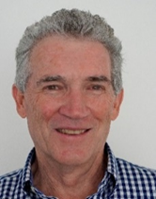**1. PRESIDENT’S MESSAGE**

I need to start this month’s message with a final request to a VERY small number of members who have not paid their $95 annual subscription for 2025/26. Please pay without further delay. It helps all your fellow members and no one likes having to chase people.

Last month I wrote of the significant personal and community benefits derived at all stages of life from the fun and fellowship we offer at Probus Warrawee.

It is important though that we members encourage fellow members to participate and not just once or irregularly, but on a regular basis.

As a great example within our own Warrawee Probus Club, our regular Luncheons are a highlight for many of our members, they have been fantastic, many of these Luncheons give you the opportunity to travel the world let alone our local suburbs for different food cuisines like our last luncheon Greek, this type of activity gives our members the chance to enjoy other cultures and hospitality as a number of our members may not wish to travel the world as much today. The Activity Leader for Luncheons Alan McDermid and assisted by Carol have enjoyed organising Luncheons by visiting all types of restaurants to sample their delights together prior to organising wonderful Luncheon venues for our members. Alan is now taking a permanent rest from Luncheons planning to allow new Activity Leader for Luncheons John Crouch a smooth takeover to allow all of our members to sample many more wonderful cuisines going forward. Our next Luncheon is due in August, join us as it’s an opportunity to get to know your fellow club members. If you need any Luncheon information just talk with our very own and engaging John Crouch.

Regular participation by members in our wide activity programme is also so important for the wellbeing of our club. Make a date to join your own Warrawee Probus Club general meeting this month, and also join in any if not all the great activities detailed in our latest (June) Wrap.

Our club Christmas in July Travel event is well under way in planning, contact our John Laird for any information.

See the latest Wrap for this month’s programme and stay involved.

Remember it’s still important to also to talk to friends and acquaintances about our Club, invite a guest to a GM or any type of activity to introduce them to what the Club has to offer.

I look forward to your company and seeing you at this Friday’s GM, 27th June.

This months Speaker Richard Barnes should be a very entertaining talk as a structural engineer with his solo kayak journey: Australia to New Zealand.

**Bruce Hughes**

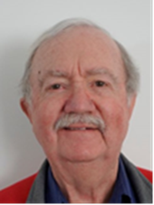**--------------------------------------------------------------------------------------------------**

**2. GUEST SPEAKERS**

* **Contact & Enquiries: Geoff Brew**
* **Ph: 0412 301 123**
* **Email: geoff.brew@icloud.com**

Our **June 2025 Guest Speaker** is **Dr Richard Barnes**.

Richard’s talk is titled: **“A solo kayak journey: Australia to New Zealand”.**

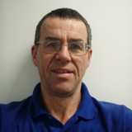

Dr Richard Barnes has been a structural engineer for 40 plus years, and a kayaker for much the same time.

One of the first unions of these two passions was competing in the World Concrete Canoe Race in Stockholm Sweden in 1980.

Richard was President of the Sydney Division of Engineers Australia in 2008. That same year he went whitewater kayaking in Nepal, paddling under and marvelling at 300m-plus suspension footbridges in areas where there were no roads.

Richard is the engineer behind BridgeClimb, and has been involved in Sydney’s tallest building Centrepoint since it opened.

Eighteen months ago he designed an ocean kayak, and paddled it from Australia to New Zealand, his most recent fusion of engineering and kayaking.

**Advance Notice:** Our **July 2025 Guest Speaker** will be a Police Officer from the PolAir - NSW Police Force Aviation Command, based at Bankstown Airport, Officer Name to be advised subject to operational needs. Polair talk is titled, **“POLAIR WORK & INSIGHTS”.**

**Geoff B**

------------------------------------------------------------------------------------------------------

**3. MEMBER update**

* **Enquiries: Bill Killinger**
* **Phone: 0407 551 600**
* **Email:** [**bkillinger@optusnet.com.au**](mailto:bkillinger@optusnet.com.au)

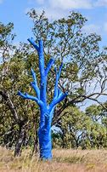

**RUOK**

Gents,

Here is the latest on Members’ welfare.

* **Dudley Luttrell**is at home now recovering from his minor stroke. His right side is still a bit of a problem for walking. Shirley sounds cheerful.
* **Bill K**and Linda flew to Europe last Sunday - and not on Air India! We hope no one starts dropping serious bombs in the Middle East while we are away. Member Support news will be sporadic from me during that time. Everyone please keep President **Bruce Hughes** informed of any notifiable matters.
* **Chris Russell**  and Gill are recovering from the RSV (which was not a good experience for them) by caravanning in North Queensland. Gosh, in one way I am glad they are well away up in North Queensland until the end of July.
* Well! North is certainly the place to go in winter, **Ken Zandona** and Judy are at the moment near the Tropic of Capricorn. Gosh he is to be commended for putting this Wrap together.
* Good to have a chat with **Ron Patton** and Cynthia in a joint telecon. They both are very cheery and well.
* **Erich Schuller**’s doctor asks him why on earth he comes to see him. So, Erich is well despite his growing old. He is envious of me going to his old country of Germany.

As I said, please pass on any intelligence you have on your fellow members to Bruce Hughes.

**Bill**

**----------------------------------------------------------------------------------------**

**NEW MEMBERS**

|  |  |
| --- | --- |
| **Member** | **Biography** |
| **Jonathon Harrison**  C:\Users\Dennis\Downloads\Jonathan Harrison.jpg | Inducted May 2025.  Editor’s note: I was provided a one-pager which I was to distil here into a few paragraphs! But alas it is at home, and I am in North Qld!! Whoops! So very sorry about that Jonathon. |
| **Vic Spagnardi** | Inducted January 2025. Vic’s story will be included once his photo and brief biography is to hand. |

**MEMBER BIRTHDAYS – JUNE**

Rodney HENDERSON

Peter FARMER

Mark TUNSTALL

John W WHITE

Vince MAKHIJA

Trust you all have/had a good one!

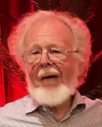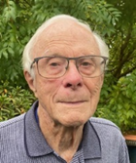**4. ADVENTURE GROUP**

* **Contact & Enquiries:**
  + **Ian Falconer M: 0407 462 171**
  + **Richard White M: 0424 603 499**
* **Email: ian.falconer@sydney.edu.au**

[**whitard@ozemail.com.au**](mailto:whitard@ozemail.com.au)

We have two exciting – but not too exciting – activities to follow up on our successful tenpin bowling last Wednesday.

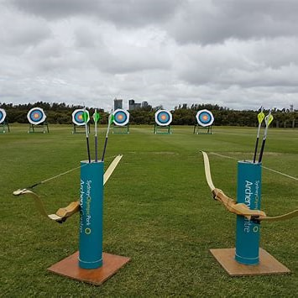**ARCHERY**

Bring out your latent Robin Hood by joining us to practice your archery skills at Olympic Park, to be followed by lunch at a nearby cafe.

**Venue**  - Archery Centre, Bennelong Parkway, Sydney Olympic Park

**When** - 20th August

**Duration** – 1.5 hours

**Cost** - $32 per person including equipment

**KAYAKING**

Join us for a morning of kayaking on the beautiful Woronora River, followed by lunch at the Boathouse.

**Venue** - The Boathouse, Woronora River

**When** - 22nd October

**Duration** – 1 hour – or 2 hours for our more active members.

**Cost** – TBA

**Ian and Richard**

--------------------------------------------------------------------------------------------------------

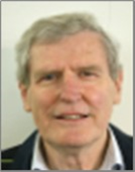**5. book club**

* + **Meets bi-monthly on the 3rd Monday of selected months**
  + **Enquiries: Mark Tunstall 0429 334 340**
  + **Email: home@tunstall.com.au**

The next Book Club meeting is

**Monday 18th August @ 10.00 am**

**Killara Golf Club – Lower Bar**

**Here are the currently nominated books**



***The Zookeeper’s War – Steven Conte* -**Fiction ***––*** Thanks to Merton Miles

***The Zookeeper's War* is a powerful novel of a marriage, and of a city collapsing. It confronts not only the brutality of war but the possibility of heroism - and delivers an ending that is both shocking and deeply moving.**

***The Valley- Chris Hammer –*** Fiction***–*** Thanks to Ian Falconer

**The Valley features a page-turning plot, intriguing characters, and an evocative sense of place-where nothing is ever quite what it seems. Chris Hammer, the acclaimed author of the international bestsellers Scrublands, Treasure & Dirt, The Tilt and The Seven, presents another immersive and emotionally rewarding thriller.**

***Four Points of the Compass- Jerry Brotton*** – Non-fiction - Thanks to James Loxton

***Four Points of the Compass* takes the reader on a journey of directional discovery. Jerry Brotton reveals why Hebrew culture privileges east; why Renaissance Europeans began drawing north at the top of their maps; why early Islam revered the south; why the Aztecs used five colour-coded cardinal directions; and why no societies, primitive or modern, have ever orientated themselves westwards.**

**Unreliable Memoirs – Clive James** – Classic – Thanks to Geoff Fitzhardinge

**In the first instalment of James's memoirs we follow the young Clive on his journey from boyhood to the cusp of manhood, when his days of wearing short trousers are finally behind him. Battling with school, girls, various relatives and an overwhelming desire to be a superhero, Clive's adventures growing up in the suburbs of post-war Sydney are hair-raising, uproarious and almost too good to be true**

**We meet, talk, drink beer/wine/coffee - have fun! Then a quick lunch.**

**Ian Falconer runs Nick’s Book Exchange at the General Meeting. Bring your old books please**

**Mark T**

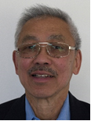**6. CINEMA & Dining**

* **Held on the first Tues and Wed following the GM**
* **Contact and Enquiries:** **Doug Chee**
* **Phone: 0415 083 613**
* **Email:** [dypc@hotmail.com](mailto:dypc@hotmail.com)

Our next **Cinema & Dining** nights are **Tuesday 1st and Wednesday 2nd July 2025.**

The preferred late afternoon session time of this English-subtitled French Comedy is not available yet from the Cinema. You will be notified once known.

*****Directed by*** *Ivan Calberac*

***Starring*** *Thierry Lhermitte, Sabine Azéma, André Dussollier, Sébastien Chassagne, Joséphine de Meaux*

*François is a former military man who is making the most of his retirement alongside his wife Annie, the only person who seems to be able to put up with his foul temper and demands! Authoritarian, and uncompromising, he rules his family with an iron fist. When he discovers that his wife, who he always held in high esteem, cheated on him 40 years ago, he sees only one solution: to file for divorce and confront her former lover who now lives in Nice. But at 73 years old, and after 50 years of marriage, is this really a good move? And wouldn’t this risk blowing up the already fragile family balance?*

**Registration**- email me your choice of either Tues or Wednesday, plus your dinner order(s) no later than **Saturday 28 June**. A copy of the Menu will be sent out by email when session times are advised.

**Remember - purchase your movie tickets at the Cinema**.

***Importantly, if you, your partner or guest wish to cancel or change your dinner orders,******please contact me immediately to inform the Restaurant.***

**Doug**

--------------------------------------------------------------------------------------------



**7. COFFEE SOCIETY**

* **Gatherings are held on the second Thursday of the month.**
* **Contact & Enquiries to: Paul Cook**
* **M. 0414 891 620**
* **Email: pmjcook@bigpond.com**

Next gathering for coffee is **Thursday 10th July @ 10am** at the **HORNSBY PCYC CAFÉ, 1 Park Lane, Waitara.** (Cnr Waitara Ave, Opposite Magpies Club and next door to KOKODA and adjacent to Waitara Oval and 50m from Waitara Station)

Free Parking under PCYC, drive in off Park Ave. Then up the stairs/lift to the Café.

A table is reserved for us in the Café or outside depending on the weather.

If you are a first timer, come and check out the venue. **All Members and spouses /partners /friends are welcome, especially new members –** it’s a great way to meet your fellow members and introduce your partners in a relaxed environment.

**RELAX and CHAT TOGETHER – Get to know other Members**

This is such a convenient location to meet, directly opposite Waitara Train Station or easy parking on the premises if you are driving. So give it a try!!

**Please let me know if you are coming so that I can arrange appropriate seating.**

**Paul**

------------------------------------------------------------------------------------------------------

**8. COMPUTER GROUP**

* **Wahroonga Probus group welcomes members of Warrawee Probus to their Computer Group meetings.**
* **This group normally meets on the 3rd Tuesday of each month.**

The next meeting of the Wahroonga Probus Computer Group will be **Tuesday 15th July 2025.**

Any Warrawee Probus members interested in attending need to **RSVP** to **Paul Wood** of the **Wahroonga Probus Club** at [purdey123@outlook.com](mailto:purdey123@outlook.com) to confirm both location of the meeting and numbers attending.

Further queries are best addressed to **John Derrett** ([john@derrett.net.au](mailto:john@derrett.net.au)) from our Warrawee Probus club.

**If you are intending to attend the Wahroonga Computer Group, please let John Derrett know as occasionally the date of the meeting gets moved at short notice.**

---------------------------------------------------------------------------------------------------------------------------------

**9. CULTURal CLUB**

* **:** [**bkillinger@optusnet.com.au**](mailto:bkillinger@optusnet.com.au)

** PROBUS CULTURAL **



**Here at The Warrawee Club**

***Wed 17th September***

**$70** per person (bring partner)

Includes a 2-course meal & presentation by Greg North

Arrive 12 noon for 12.30pm seating

Tell Bill K [**bkillinger@optusnet.com.au**](mailto:bkillinger@optusnet.com.au) **0407551600**

Pay to Warrawee Probus Account BSB 032189 Account 751903

**Bill**

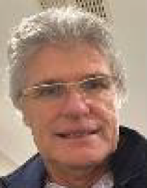**------------------------------------------------------------------------------------------**

**10. FINANCE GROUP**

* **Meet the first Friday of every second month**
* **Enquiries: Rory Gray 0427 660 135**
* **Email: rorygray53@gmail.com**

Interested in matters financial? Then consider coming to the next ***Finance Group*** meeting:

**Friday 1st August 2025 @ 10:00 am**

**Venue: The Warrawee Club, Pacific Highway, Warrawee**

**Cost: Please bring along $12 to help defray the room hire and morning tea/coffee charge.**

An interesting and stimulating range of topics impacting finances were collectively discussed at our last meeting including Trumpism, Aust. Shares, Aust. Elections, Real Estate and the Share Game, solar batteries, superannuation, post-election impacts and local plus global markets. Topics on the agenda for next meeting include retirement accommodation options/issues plus superannuation trustee requirements..

**The Aim of the Group:** To discuss a range of topical and informative finance related subjects in a friendly relaxed informal atmosphere. Whether you are experienced in personal finance or simply want to know more about aspects of the world of money matters you are most welcome to attend.

**Rory**

**11. FISHING**

* **Meet second Friday of each month**
* **Contact & Enquiries: John Laird Ph 0402 476 101**
* **Email:** [**jlaird@conicklaird.com.au**](mailto:jlaird@conicklaird.com.au)

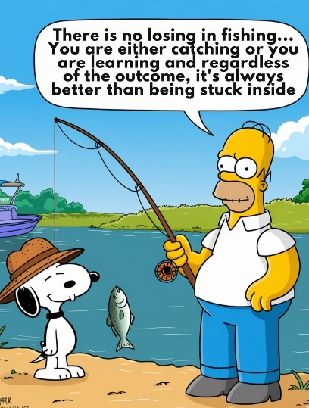

Fishing will start again on **Friday 11th July** @ **10:00am** at **Dunlop Reserve** in Drummoyne (next to Drummoyne Sailing Club), followed by lunch at the Sailing club.

Fishers and lunchers are all welcome, particularly new members – please let me know if you intend coming along so that we can keep an eye out for you.

**John**

**---------------------------------------------------------------------------------------**

****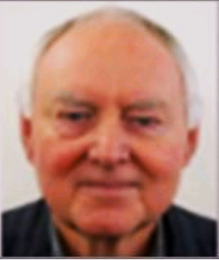**12. FItness by zoom**

* **Contact & Enquiries: John Laird Ph 0402 476 101**

**Paul Gill Ph 0418 363 585**

* **Email:** [**jlaird@conicklaird.com.au**](mailto:jlaird@conicklaird.com.au)

**pagill@telstra.com**

**ZOOM Fitness**

(in conjunction with **Mike Adams** from **Pymble Gym** )

**Tel. 0422 716 113** [**michael@lobef.com.au**](mailto:michael@lobef.com.au) )

Contact participating members John Laird or Paul Gill if you would like to discuss.

Features:-

* Presented live, in your home, by ZOOM – via your mobile, tablet or laptop. Mike will assist you with access.
* Each session will be for one hour commencing **7:00am** **each Wednesday**.
* Limited requirements eg. hand weights can be arranged
* Cost **$12 per session**. Arrange billing directly with Mike.
* Sessions are social, yet purposeful for our ages, our needs and condition.

Seven members are currently participating!!!

**John and Paul**

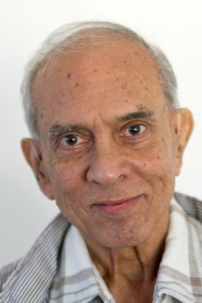**13. LUNCHEONS**

* **Generally held on the fourth Thursday of selected months**
* **Contact & Enquiries: John Crouch**
* **Mobile: 0403 599 078**
* **email :** [**ja.crouch@optusnet.com.au**](mailto:ja.crouch@optusnet.com.au)

The next Luncheon is on **Thursday 28th August 2025.**

***NORTH RYDE GOLF CLUB***

|  |  |  |  |  |
| --- | --- | --- | --- | --- |
|  |  |  |  |  |
|  |  | https://www.northrydegolfclub.com.au/upload/wysiwyg/enews-upload/2024/New%20Header%20News%20Letter%2075%20anniversary%20(750%20x%20315%20px).jpg |  |  |

Enjoy a *3 course meal, washed down with Barista made coffee or tea*

The club’s restaurant overlooks a manicured golfing green and very attractive, relaxing water feature/fountain which can be viewed from our dining tables.

*Here’s all you need to know –*

|  |  |
| --- | --- |
| **Cost:** | **$61 per person** |
| **Bookings:** | **Please let me know by Wednesday 20 August by email (preferred) or phone and…** |
| **Payment:** | ….**pay not later than that date** by bank transfer to the Club’s Account: BSB 032189 Account 751903.  *Insert your surname as the reference.* |
| **Address:** | Twin Road, North Ryde NSW (off Lane Cove Road). |
| **Parking:** | 2 separate entrances including one at the very front of the club if you need to drop someone off first. |
| **Wheelchairs?** | Yes, wheelchair friendly (refer also ‘Parking’ above). |
| **Car Pooling** | Coming by car? Why not car pool? Could you give a lift to other members? If you need a lift please call me and I will be happy to explore transport options. |
| **John** |  |

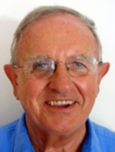**14. MUSIC GROUP**

* **Meets by Zoom first Monday of each month**
* **Contact and enquiries: Bill Killinger**
* **Mobile: 0407 551 600**
* **Email:**  [**bkillinger@optusnet.com**](mailto:howferr@gmail.com)**.au**

**In conjunction with Ian Falconer and Geoff Fitzhardinge**

Zoom Music is taking a holiday in July but is **back on Monday 4th August **

**Yes, 2 pm on Monday 4 Aug – by Zoom.**

**Stay in your own home and just look and listen – it is always very enjoyable and interesting**

**Presenters will be PETER BARBER, DOUG CHEE and DAVID PRICE.**

**Yes! David Price is a non-member now in Port Macquarie but he likes Probus Music so much he cannot let go!!**

**Let’s see what their respective choices of music are.**

**Geoff Fitzhardinge arranges and hosts this scheduled ZOOM meeting**

Topic: Probus Music Zoom Meeting  
Time: Aug 4, 2025 02:00 PM Canberra, Melbourne, Sydney  
Join Zoom Meeting  
  
<https://us02web.zoom.us/j/83248367597?pwd=LOl7Loy7fWcTnA7ZsBFAIeuin3XYyS.1>  
  
**Meeting ID:** 832 4836 7597  
**Passcode:** 069449

**No need to give notice – just ZOOM in on the day**

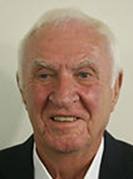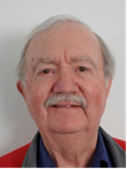 **15. OUTINGS**

* **Contact and Enquiries: Geoff Brew / Keith Walker**
* **Phone: 0412 301 123 / 0419 429 322**
* **Email: geoff.brew@icloud.com**

**walker.keith.ian@gmail.com**

**TOUR OF THE STATE THEATRE**

**Tuesday 8th July**

**The Outing:**  Is a 2 1/2 hour guided tour starting at **10.00 am**

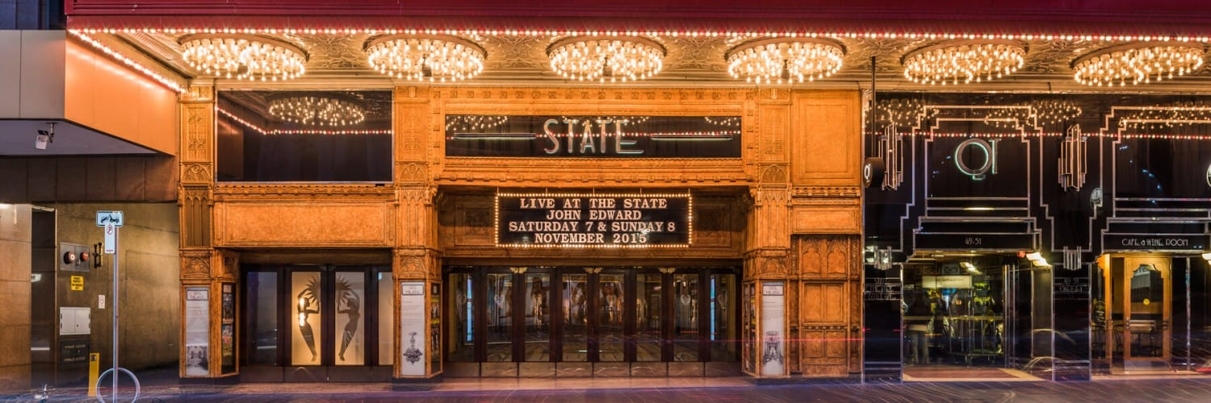Sydney’s most iconic venue for film, theatre, music and more.

Since its opening in 1929, the State Theatre has captured the hearts and minds of patrons with its majestic elegance.

During the tour, you will:

* Experience the grandeur of standing in a 2000 seat auditorium beautifully framed by 13 hand-cut crystal chandeliers
* Observe the eclectic elements of the Theatre’s Gothic, Italian and Art deco design
* Discover the State’s famous Character Lounges including the exotic Butterfly Room, the Pioneer Room, College Room and more
* Be mesmerised by the world’s second largest hand-cut crystal chandelier, the Koh-i-No
* See the original mighty Wurlitzer Organ, the voice of silent movies (pending availability)
* Admire prize winning artworks by famous Australian artists including William Dobell, Mary Edwards, Charles Wheeler and Raymond Lindsay
* Delve into the depths of the Theatre to discover engineering marvels and mechanical masterpieces

**Getting there:** Take a train to Town Hall Station.

**Meeting Point:** At **9.15am** meet for a coffee at the “Waterfall Café” (8068 0058 – shop 15, underground next to the station under Town Hall Square. Then either walk to the theatre in Market St or take the tram one stop from the front of the Town Hall. Tour starts at **10.00 am** sharp.

**Lunch:** Booked at the “Waterfall Café”, to your account.

**Cost:** $30 per person

Please advise Keith or I by **1st July** if you are coming, to facilitate tickets.

**Advance notice:** Our next Outing will be a tour of the **Metro** on **August 12**.

**Geoff Brew**

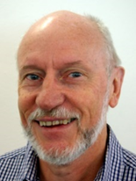**16. PHOTOGRAPHY**

* **Meets third Thursday of each month**
* **Contact and Enquiries: Alan McDermid**
* **Mobile: 0409 285 859**
* **Email: candamcdermid@outlook.com**

**Photo Review Meeting Thursday 17 July**

The masterpieces captured in and around the Maritime Museum will be reviewed on Thursday 17 July at 10:00 am at my home in Lindfield. **95a,Bent St ,Lindfield 2070**

Happy snapping

**Alan**

**----------------------------------------------------------------------------------------**

**17. TOURs**

* **Contact & enquiries: John Laird 0402 476 101**
* **Email: jlaird@conicklaird.com.au**

**CHRISTMAS IN JULY experience**

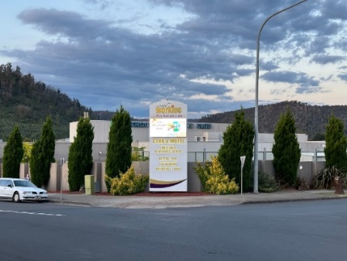**Wednesday 30th July 2025**

**AT LITHGOW WORKIES CLUB and MOTEL, 3/7 Tank St Lithgow.**

**Dinner, Bed, & Breakfast**

**Double/Twin Share $360.00 ($180.00 per person)**

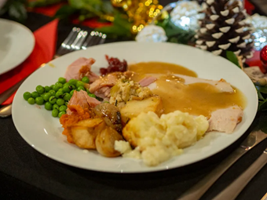**Single $290.00**

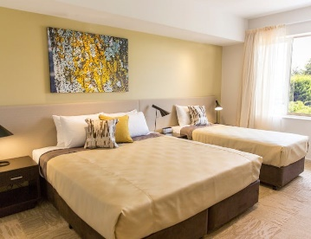

**Christmas In July Dinner**

* **bread Roll**
* **Baked Dinner**
* **Desert**
* **Tea & Coffee**

**Come by train $2.50. Relax on board the comfortable intercity train for the approx. 3 hour trip from Central and enjoy the scenery of the Blue Mountains; OR**

**Come by car – drive yourself or ride share. Take a round trip via the Great Western Highway and return via Bells Line of Road or vice versa; OR**

**Mix and match – by arrangement.**

**IMPORTANT NOTE. This tour is now filled with 30 members and partners participating BUT if you are still interested to attend, let me know and I will investigate availability**

**The proposed Mallacoota tour has been cancelled due to insufficient interest.**

**John**

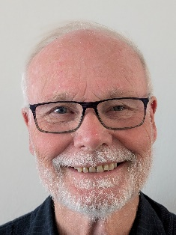**18. WALKS & EXPLORE**

* **Walks are held on the first Thursday of each month**
* **Contact & Enquiries : James Loxton M: 0412 559 395**
* **Email : jamesaloxton@gmail.com**

Our next walking adventure will be on **Thursday 3 July 2025**, though perhaps not as adventurous as the Cascades walk. This time we will meet at Barangaroo at 9.45am for coffee before boarding the ferry at 10.16 for Balmain East. We will then wander through Balmain, Birchgrove and Rozelle before crossing Iron Cove Bridge, ending at Birkenhead Point. We will take in Ballast Point and, if time permits, we will walk alone Louisa Road to Birchgrove Point.

**Advance Notice:** I have not yet settled on the August walk. Most likely, I will re-schedule the North Head walk or we may do another local walk along Lovers Jump Creek

**James**

-----------------------------------------------------------------------------------------------

 What rot – how would dogs look like humans!!

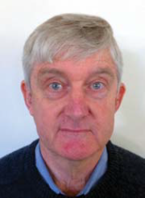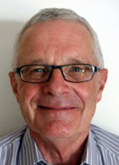**19. WEBSITE**

**Contact & Enquiries :**

* **Geoff Fitzhardinge Ph 0418 973 583** [**gglfitz@gmail.com**](mailto:gglfitz@gmail.com)
* **Bob Cooper Ph 0418 449 013** [**rcooper@cooper.com.au**](mailto:rcooper@cooper.com.au)

****The Probus Warrawee website is via [**www.probuswarrawee.org.au**](https://deref-gmx.com/mail/client/Vq2DvHBVuek/dereferrer/?redirectUrl=http%3A%2F%2Fwww.probuswarrawee.org.au)

**scan this on your smart phone:**

and it will take you to the website!

The “Members Only” page is however restricted to **Members who are registered**. When you tap on the “Members Only” page link you use ***your email address*** and your own **nominated password**.

To register (to access the “Members Only” page) all you need do is click on the “Members Only” page link and follow the instructions to “Sign Up”. This sends an email to the webmasters to set up your membership log-in. You won’t get an instant response but once actioned by one of the webmasters you will be a ‘registered’ member so you can use your email address and nominated password as above.

The **probuswarrawee.org.au** web page also contains members’ own stories under the heading **Meet your fellow members**.A great opportunity to get to know your fellow members. Remember, fellowship and friendship is what we are about.

**Members should also look at the website for event updates.** The “COMING EVENTS” page provides a snapshot of all activities. And it provides a link to the latest WRAP.

**Geoff F and Bob**

--------------------------------------------------------------------------------------------

**20. WINE & CHEESE CLUB**

* **Dates as advised**
* **Contact & Enquiries: Roger Goozee**
* **Mobile: 0405 505 339**
* **Email: goozeer@bigpond.com**

The next Wine & Cheese gathering is

**Tuesday 19th August 2025 @ 2.30pm**

At Alan & Carol McDermid’s place, **95a,Bent St ,Lindfield 2070**.

We will be tasting white wines made from grape varieties that have originated from Italy.

And red wine made from Cabernet Sauvignon from any area.

A selection of cheeses and crackers will accompany the wine.

**Remember to please let me know if you intend to attend.**

**Roger**

**RALPH’S HINTS AND TIPS**

**EOFY**. It is the near the end of the financial year, so many stores & businesses have specials – clothing, furniture, electrical things as well as new cars etc. So, if you need any of these, shop around and save some money.

**Income Tax**. It is coming to tax time again (due end of October). If you do your own return, it is easy, but wait a few weeks to start, in order to give the tax office time to input all the items they can and for other institutions to prepare your statements up to 30 June.

**Fuel** is likely to go up again due to overseas conflicts. Use <https://motormouth.com.au/> or another ‘fuel price site’ to find the best prices.

**Electricity**. No surprise – prices are going up again! Service NSW has a comparison check site. <https://www.service.nsw.gov.au/referral/compare-energy-plans-with-energy-made-easy> also check out other rebates at Service NSW.

**Insurances** and purchases. Compare before you buy! You could save quite a bit.

**Scams** Be careful you don’t get caught by dodgy emails, texts or phone calls. See earlier reminders.

Do you have any advice to share, please let me know.

**Ralph Mackie**

----------------------------------------------------------------------------------------------

Don’t simply retire from something; have something to retire to.

Retirement is a blank sheet of paper. It’s a chance to redesign your life.

Often when you think you’re at the end of something, you’re at the beginning of something else.

The trouble with retirement is that you never get a day off.

You know you’re ready for retirement when your aptitude test says ‘afternoon nap.’

“Age is an issue of mind over matter. If you don’t mind, it doesn’t matter.” — Mark Twain